DEVIKA.B
ROLL NO:22

14. Create a new directory, dir6 inside dir1
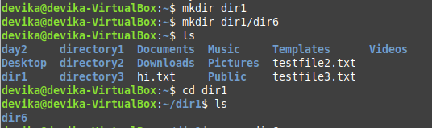

(a) Move all files in dir5 into it.

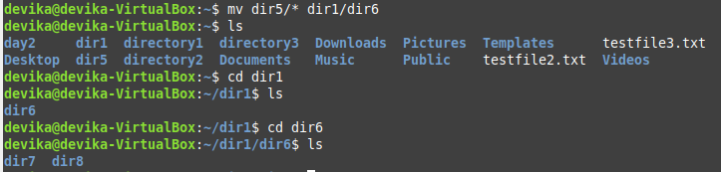

(b) Rename the file newfile in Qn.4 to oldfile

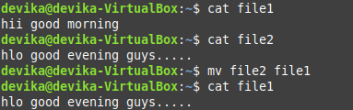

(c) Move the file file1 in Qn.4 to dir6 with the name file3

(d) Delete all files where name starts with a vowel character, upper or
lower case.

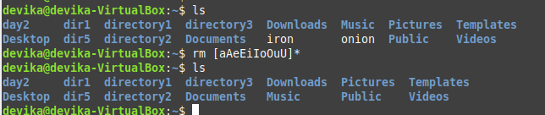

(e) Delete all files where the name is at least 3 characters long.
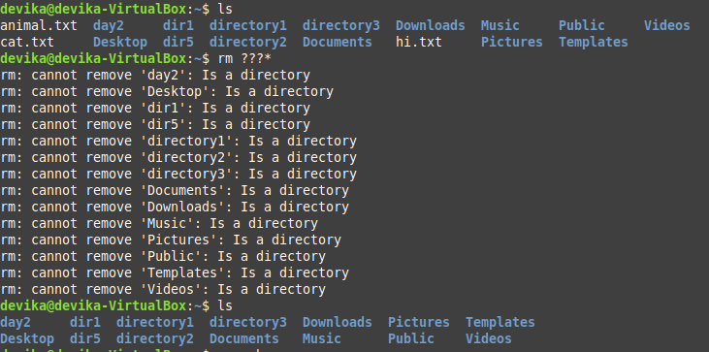

(f) Delete all hidden folders, and files.
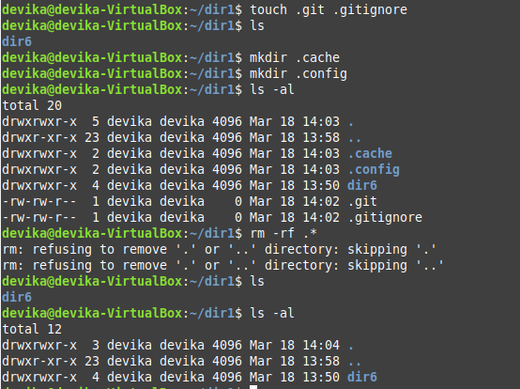

15. Using cut filter
(a) Display the filenames from ls -l assuming filenames start at column 50.

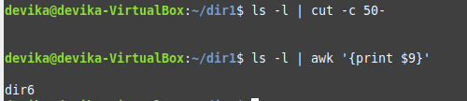

(b) Display user Id and user name of all users from /etc/passwd. (fields 1 and 3)

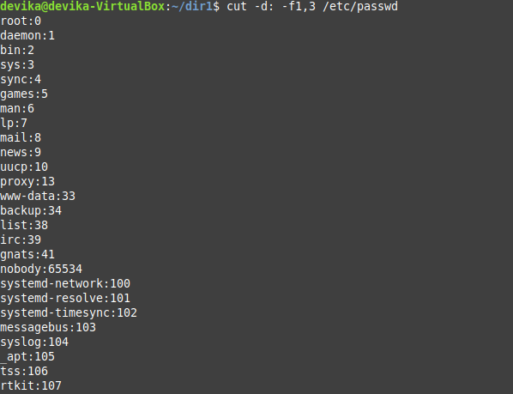

16. Create 3 files containing name, age and marks of 5 students respectively and paste them into a single csv (comma separated values) file.
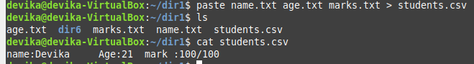

17. Using find
(a) piped with wc, display the number of files in a directory that starts with the letter a

(b) Delete all .c files in the parent directory

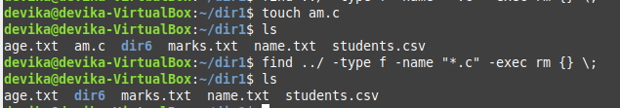

(c) Copy all files that starts with a to dir2

(d) Display files in the current directory that were modified in the last 30 minutes.

18. Use head and tail piped with cat /etc/passwd to display the details of
(a) The first 12 users in the system.
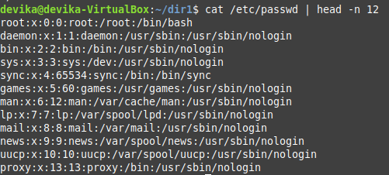

(b) The last 7 users in the system.
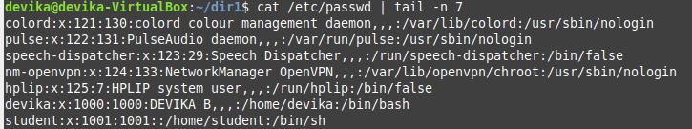

(c) All but the first 3.
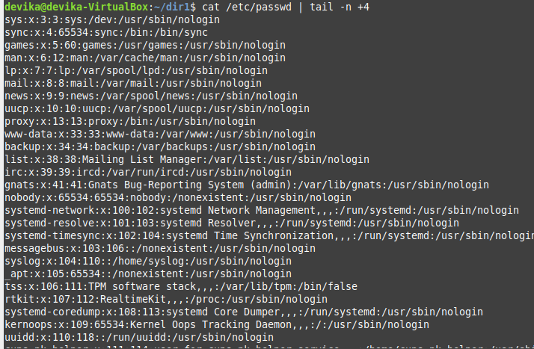

(d) All but the last 5.
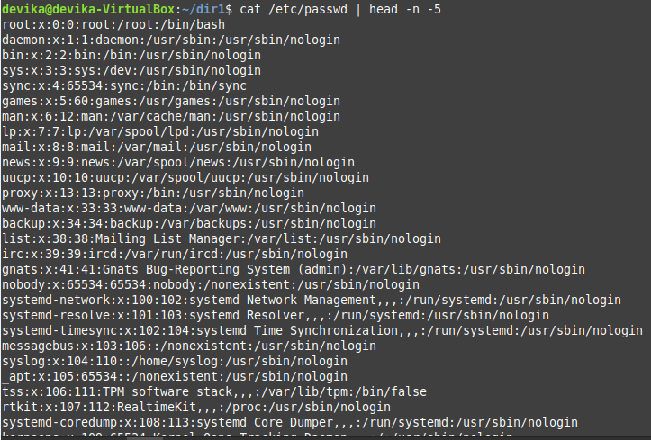

(e) Only the 9 th .

19. Use grep to

(a) Display all lines in a file that contains the string abc

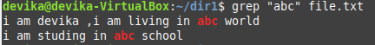

(b) Display all lines in a file that does not contain the string abc

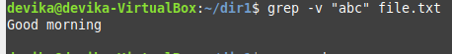

(c) List names of all .c files that contains a printf

(d) List names of all .c files that does not contain a printf

(e) Display the number of #include statements in each .c file.

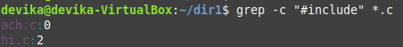

(f) Display the Line numbers of printf in a .c file.

(g) List names of all files in the directory tree that contain a printf.

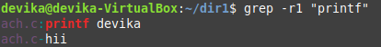

(h) Display the context of every printf in a .c file. i.e., n lines before and after every printf.

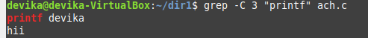

(i) ls -l starts with d for directories. Use ls -l piped with grep &amp; cut to display the names of all directories in the current directory.

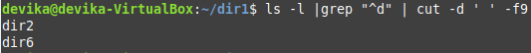

20. Using expr
(a) Read two integers X and Y . Display the sum, difference, product, quotient and
remainderof these variables.

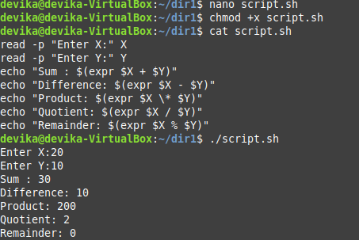

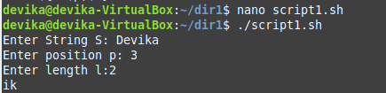
(b) Read a string, S, a position, p and a length l. Display the substring of length l starting atposition p from the string S

